**Usability testing of VR games on Kids**

Maha Raza, Rida Hamid

**Jinnah University,5-C,Nazimabad,Pakistan**

**Abstract**

Virtual reality is an innovative and interactive tool for children. The gameis the new or additional part or attributes through the children get motivation, interaction, score and challenge. This technology in the future can be changed in the full body interaction system that should increase more participants towards it. This is the new experience for kids. Kids and virtual reality it sounds tremendous that there is a remarkable advance in technology and children are able to do exercise by moving their head to play the game. Through this technology by playing the game make their body active. For testing the usability of the game through virtual reality in the game used two different games. The first game is VR subway run andthe second game is VR thrills: Roller Coaster 360 (Google cardboard). The sale of VR devices increases day by day it becomes popular and famous. The peoples are like to use it. The parents buy this for their kids so it becomes good for the health consults that remove their laziness and make them active. But there are some parents that are still not ready to buy this for their child because they think it puts negative impact on their children in the sense of characters in that case prefer that there are some character that influenced the children towards the pleasant of world and see them a world how beautiful is the world but at the same way there are some negative characters that can influence their children towards the badness of world and learn them a bad things.

**Keywords:** Virtual reality, physical activity, Google Cardboard, laziness, negative impact, computer-generated simulation

**Introduction**

Virtual reality is a technology or concept which is used via a headset that takes power from a mobile phone or this can be a separate handset.Through this everyone is going on that world that

Everyone thinks it is real e.g. download apple tower app and wear the handset that it feels you are in apple tower where all side in Paris. Feel like we are the part of this activity but it is not real we stood where we actually stand. A virtualreality basic example is Google cardboard when you wear glasses there is two part of the screen where each thing that open that show on both which side it moves we think we are goingon that direction. Virtual reality is that you do not go anywhere this work happen through video content app or software you feel you are part of another world. Children are doing a physical activity by moving their head to play the game. It has two-parts reality means which happen in real and virtually means something is in an imaginary form that is not in reality. For virtual reality need two thing the one is hardware that can be a headset or device and the one is software. There are multiple softwares that are developed to use the VR device or technology. VR is a computer-generated simulation that works for a 3D environment. For testing the usability of VR game on children making the task set that is done by children. For this research target the children whose age from 8 to 15. The children are getting great experience to use it. It becomes a way of pleasure, motivation, and fun. The game is the best way to interacts the kids towards it, so provide VR base games to that provides the new experience. First-time children understand that this is a video then taught them how to play? The children do not believe that it is true that the game is playing with head movement. Then it happens they get knowledge about something that is the part of advanced technology. Only one time teach children it’s learn ability is good so next time does not need to tell the children that how to play this and another thing it is easy to use. The memory ability of the VR game is good.

**Usability evaluation with users:**

After evaluating the VR device manually and check the VR game and write some important aspects manually. Write some aspects that used games that create enjoyment, fun and become a new experience for the targeted users. Then include the users that are the targeted children whose age from 8 to 15. Then ask the children which problem you face to play the VR game through VR device? Then ask questionnaire and fill it by their user experience. Note the time and

error rate that faces to the children. Try to find the approach to resolve the issues why only head movement it works there are certain body parts which should be allowed to play the game because the children feel tire to play the game continuously with the head.

**Methodology**

**Participants:** 23 participants took part in this evaluation. The 12 are the kids from school and 12 kids are the nearest people from our residence. The kid’s ages range from 8-15; this age was decided to know actual experience accurately and easily.

**Equipment and software:** This evaluation was performed using VR and mobile phone device. The mobile phone is supported by the Android platform. We installed two applications on mobile phone 1) VR Subway 2) VR roller coaster. Then we insert the mobile phone on a VR device to check the experience of Kids.

**Task set:** The following tasks provided to the kids are:

1. Choose the application.
2. Wear the device.
3. Use the device by moving your head.
4. Answer some questions.

**Procedure:** We perform an evaluation on school and some kids from our nearest residence. The most challenging task was visiting the school. We ask for permission from the principle of the school to perform an evaluation on kids but they were having exams but we got 1 hour before the exam start. So within an hour, we perform an evaluation on 12 students their ages was among 8 to12.

**Result and Discussion**

The results are shown in the following figures

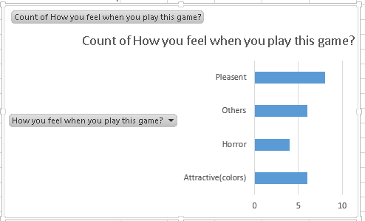

Figure 1

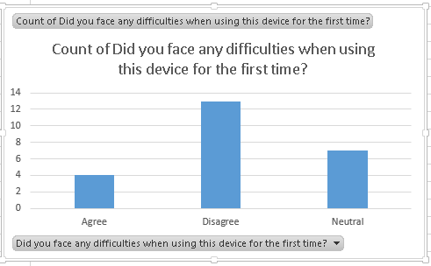

Figure 2

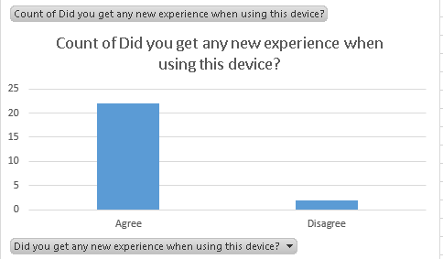

Figure 3

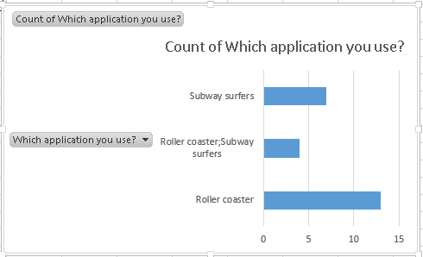

Figure 4

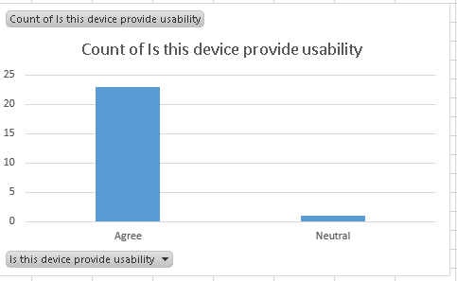

Figure 5

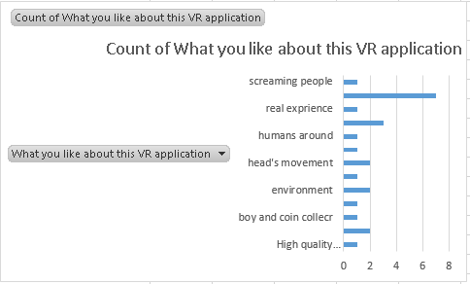

Figure 6

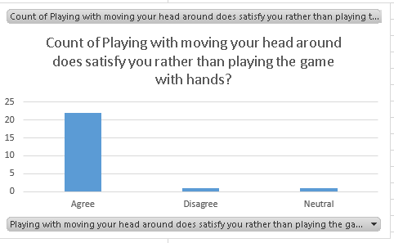

Figure 7

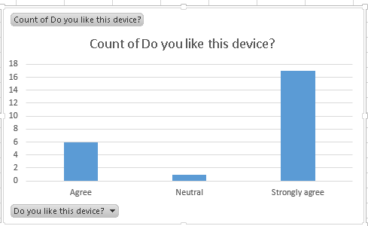

Figure 8

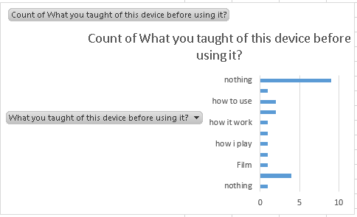

Figure 9

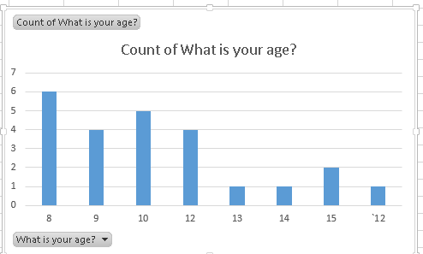

Figure 10

**Evaluation**

The evaluation was done on kids, their answers were filled out on Google forms and we get the following results. As you can see that 100 percent kids found this device enjoyable and they didn’t even face any worst experience when using this device. These kids have seen this device for the first time and they don’t even know that this device could provide the real experience. As we asked them that if they enjoyed playing this device more than using hands. So they were agreed on this opinion because this device provides usability and no one faces any kind of difficulties except some kids might not know that to play with this device they have to tilt their head. As you can see in the graph less number of kid’s faces difficulties but still they found this experience enjoyable and real environment.

**Observation**

During evaluation it is observed that when kids saw this device for the first time they didn’t knew what it was but when they started using it, the experience was enjoyable. First they have to choose the applications 1) Roller Coaster 2) VR Subway. Most of them chooses roller coaster to feel the real experience of roller coaster rides in their schools rather than going amusement parks.

**Related work**

The new reality of virtual reality and the potential youth- to check that how they feel after using this device. Some users faces health issues, they found headsets heavy, might hurt themselves and addiction but with the help of this device they can explore many things without any danger. This work is done by **Touchstone research**.

**Enhanced future work**

There isa lot of work done on virtual reality. The designers and developers set their mind to do advancement in VR. There will be a future enhancement that can in upcoming time is that the device will be controlled by full body movement. The movies will be shown by virtual reality. There will be multiple technologies that mixed with VR to gives business, education and many fields a study in a way of entertainment and drama. VR will become the story of human mastering our senses. There is a lot of work happening to make VR as part of our daily life. The developers and designers are finding the app that can use by VR on a daily basis

**Conclusion**

After study about VR device, getting a new experience it seems to unexpected that there is a technology through which it feels that there is a world where we belong but it is not in actually it just a video content or VR based games. When testing the usability on kids then getting know that kids get too much enjoyment to play the game with VR device. This game not only give them pleasant or enjoyment it also makes themselves active because on the other (lister, 2015)this can be an exercise in which the game is played by movement of the head. The usability of VR is good one time taught the kids they never forget that how to use it so its learn ability is good at the time of use.

**Acknowledgment**

The students of SE 2016 would like to say thanks to the teacher of this course for the corporation by teaching us basic aspects and goals of usability that help us in writing the research paper and by getting agree in our ideas regarding the topic and accepting our proposal. The guidance regarding topic gave by her is really helpful to test the usability of VR game on children.

# Reference

Burch, A. (2015, july 8). *New Reality of Virtual Reality (VR) and the Potential with Youth*. Retrieved from touchstoneresearch: http://touchstoneresearch.com/infographic-the-new-reality-of-virtual-reality-and-the-potential-with-youth/

Guixeres, J., Saiz, J., & Alcañiz, M. (2013). Effects of Virtual Reality during Exercise in Children . *Effects of Virtual Reality during Exercise in Children* , 20.

lister, J. (2015). *Children and Virtual Reality:Emerging possibilities and challenges.*

Ohlsson, Stellan, Moher, T. G., & Johnson, A. (2000). "Deep learning in virtual reality: How to teach children that the Earth is round.". *Twenty-Second Annual Conference of the Cognitive Science Society*, (p. 5).

Vogel, J. J., Greenwood-Ericksen, A., & Bowers, C. A. (2006). Using Virtual Reality with and without Gaming Attributes for Academic Achievement. *Journal of Research on Technology in Education* , 14.